EQUILIBRIUM LIQUID VAPOR IN BINARY SOLUTIONS

Ideal solution

If two liquids A and B are close in chemical properties, then the forces of interaction between homogeneous particles A-A, B-B will be of the same order as between dissimilar particles A-B. In this case, the formation of a solution occurs without a change in volume and is not accompanied by a noticeable thermal effect. Such solutions are called ideal and obey Raoult's law in the entire concentration range, i.e. the partial vapor pressure of each component at any temperature is proportional to its molar fraction in solution:
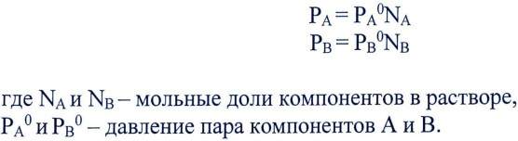
- mole fraction of components in solution,
- the vapor pressure of components A and B.

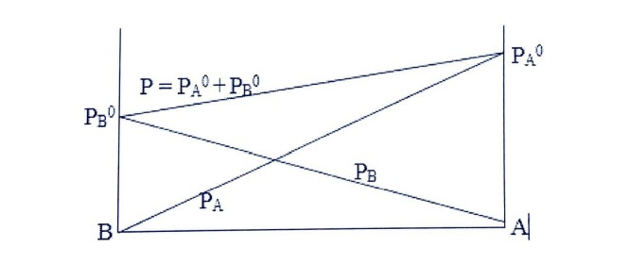
The total vapor pressure above the solution is equal to the sum of the partial pressures. The dependences of both total and partial pressures on the composition of the solution are straightforward (Fig. 1).
Fig.1 Dependences of the total and partial vapor pressures on the composition for an
ideal system.

Imperfect solutions
In real systems, both positive and negative deviations from additivity can be observed. Positive deviations of the total vapor pressure are usually observed when the forces of interaction between homogeneous particles are greater than between dissimilar ones; this is observed when one of the components is associated. For example, if component A is associated, then when component B is added to it, the An-nA process shifts to the right, i.e. in the presence of component B, the number of particles of component A increases (from one associated particle An, n monomer particles are formed), and in addition,
since the volatility of simpler particles is usually higher. Thus, the addition of component B to the associated liquid A leads to the formation of a larger number of more easily volatile particles and, naturally, the vapor pressure of such solutions will be greater than that calculated by the Raoult equation. The partial pressure of component B will be greater than the additive value; the number of particles of component B remains the same, but the total number of particles in the system decreases and, therefore, the concentration of component B will increase.
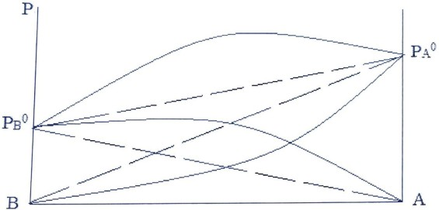

Fig. 2 Dependence of the total and partial vapor pressures of the components A and B of the composition during the formation of associate An.

If the forces of interaction are between homogeneous components, then the system will observe a negative deviation from additivity. This is observed when the components of the system enter into chemical interaction. Then the results of the process
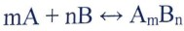

the number of particles decreases (m particles of component A and n particles of component B give one compound particle) and, in addition, the resulting compound particles have less volatility. Therefore, the total vapor pressure above the solution will be less than that calculated according to Raoult's law (Fig. 3). The nature of the deviations of the partial pressures of the A and B components will be determined by the stoichiometric coefficients. If m = n = 1, then the partial pressures of the common components will be lower than the additive ones (Fig. 3) 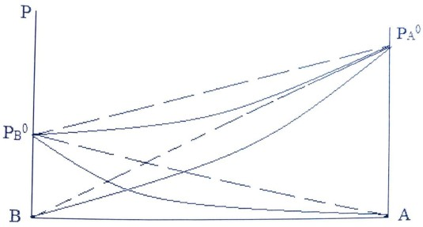.

Fig.3 Dependences of the total and partial pressures of the components of the pressures of components A and B on the composition during the formation of the compound AB.

And this is natural, since the equilibrium concentrations of components A and B as a result of the interaction become less than the initial ones: some of the components A and B are spent on the formation of a compound. If one of the stoichiometric coefficients is not equal to one and, for example, a compound of composition A2B is formed according to the equation:

then in the region rich in component B, positive deviations from additivity will be observed (Fig. 3a).
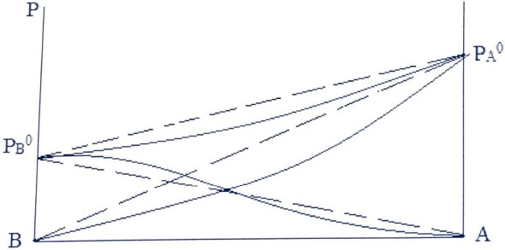

Fig.3а Dependences of the partial pressures of components A and B on the composition during the formation of the compound А2В

This is explained by the fact that the formation of the A2B compound of component A is consumed more than B. Therefore, in the region rich in component B, the total number of particles in the system decreases more strongly than the number of particles of component B. This leads to an increase in the concentration of component B compared to the initial one and to positive deviations from additivity.

Boiling Point Charts - Composition
For any liquid mixtures (ideal and not ideal), the rule known as the first Konovalov's law applies: vapor, in comparison with a liquid in equilibrium with it, is enriched with that component, the addition of which to the liquid increases the total vapor pressure (or lowers the boiling point of the solution at a given pressure). The difference in the composition of vapor and liquid in two-component systems is based on their separation by distillation. Figure 4 shows the dependence of the boiling point of the solution on the composition of the AB system.
Curve 1 shows the dependence of the boiling point on the composition of the liquid phase - liquid line. Curve 2 - vapor line, shows the composition of the vapor in equilibrium with the liquid. The areas between these two curves correspond to heterogeneous liquid-vapor equilibrium. The mn line connecting the points corresponding to the compositions of two phases equilibrium at a given temperature (vapor and liquid, respectively) is called a node. If the total composition of the system is expressed, for example, by the point K, then the amounts of the liquid and vapor phases can be determined by the lever rule.
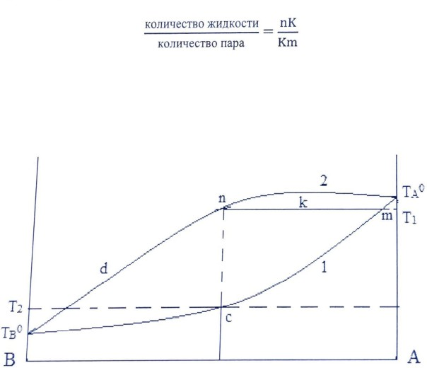

Fig. 4 Boiling point diagram - composition

The ratio of the equilibrium amounts of liquid and vapor is equal to the ratio of the opposite segments of the node. In order to carry out the distillation of the solution, the vapor obtained by boiling the liquid is subjected to gradual cooling, leading to the successive enrichment of the vapor with a more volatile component. Let us assume that the molar fraction of component B, compared with the original solution. The steam is separated and cooled, whereby it

condenses (point C). The resulting condensate boils at a lower temperature than the original solution (m2). At this temperature, steam is separated even more enriched in component B (point D). By performing this operation many times, it is possible to obtain condensate close in composition to component B. The liquid in the distillation flask will gradually be enriched with a less volatile liquid, component A. The degree of separation depends on the differences in the boiling points of the two components and in the compositions of liquid and vapor.
If the deviations from ideality are large, then on the curves of vapor pressure - the composition may appear a maximum with positive deviations from Raoult's law or a minimum with negative deviations. The appearance of a maximum or minimum is possible and not with significant deviations from ideality, if the vapor pressures of the pure components are close.
The second Konovalov's law is applicable to such systems: the point of maximum or minimum on the total vapor pressure curve corresponds to the solution, the composition of which coincides with the composition of the vapor in equilibrium with it (Fig. 5) corresponds to the minimum on the boiling point curve - composition (Fig. 6).
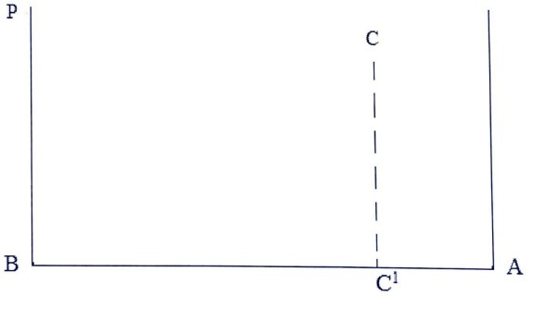
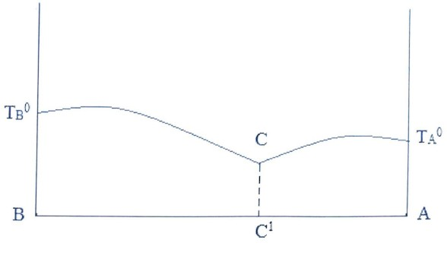
Fig. 5 Dependence of the total vapor pressure on the composition

Fig. 6 Dependence of boiling point on composition

Solutions corresponding in composition to these extreme points are called azeotropic (inseparably boiling). Their composition does not change during boiling and the boiling point at a given external pressure remains constant, as in pure substances. But unlike pure substances, a change in external pressure leads to a change in the composition of the azeotropic solution, this indicates that the azeotropic mixture is not a chemical compound. In the presence of experimental points, complete separation of the mixture by distillation is impossible. During fractional distillation of systems with the composition on the temperature curve (Fig. 6), the composition of the distillate gradually approaches azeotropic, and the liquid in the distillation flask is enriched with the component that was in excess in the initial solution compared to the composition of the azeotropic solution. If the composition of the initial solution corresponds to a point lying in the interval BC1 (Fig. 6), then the liquid is enriched with component B, if it is in the interval C1A, then component A. In systems with a maximum on the temperature-composition curves, the distillate is enriched with the component, which was in excess compared to the azeotropic mixture, and the azeotropic solution accumulates in the distillation flask.

Measurement technique
In dry conical flasks, prepare solutions of the two components with a total volume of 5 ml, the ratio between the volumes of components A and B should be as follows: 1: 4, 2: 3, 3: 2, 4: 1. The first and last flasks measure the refractive indices of pure liquids of their mixtures and the obtained data are plotted in the coordinates composition (in mol%) - refractive index (Fig. 7), i.e. calibration curve.
The composition of the mixture in molecular percentage is calculated using the following equation:
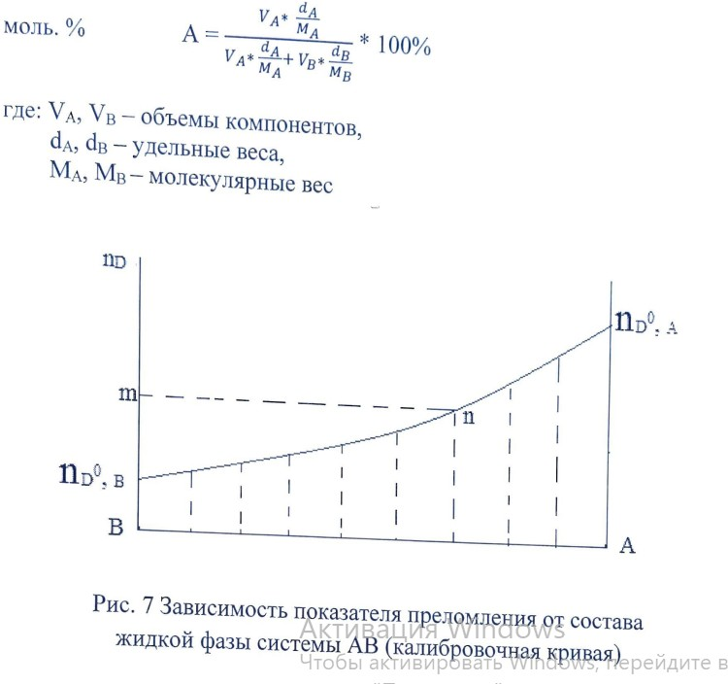

Next, the pure liquid or the prepared mixture is poured into an ebullioscope equipped with a thermometer and a reflux condenser and its boiling point is determined. After determining the boiling point of the mixture, the reflux condenser is turned downward so that a few drops of condensate can be taken into a previously prepared test tube with a thin section and the refractive index of the condensate is determined (only for mixtures). This is done in order to determine the composition of the steam. Then we postpone on the ordinate the value corresponding to the value of the refractive index of the condensate (m) and then from this point draw a straight line parallel to the abscissa axis until it intersects with the calibration curve (n), from the intersection point we lower the perpendicular to the abscissa axis and determine the vapor composition (n ") (Fig. 7). After sampling, it is necessary to determine the boiling point of the liquid again in order to make sure that the composition of the liquid phase has changed little. The difference in boiling points before and after sampling should not exceed 1-1.5 C. enter in the table of the following form:Next, the pure liquid or the prepared mixture is poured into an ebullioscope equipped with a thermometer and a reflux condenser and its boiling point is determined. After determining the boiling point of the mixture, the reflux condenser is turned downward so that a few drops of condensate can be taken into a previously prepared test tube with a thin section and the refractive index of the condensate is determined (only for mixtures). This is done in order to determine the composition of the steam. Then we postpone on the ordinate the value corresponding to the value of the refractive index of the condensate (m) and then from this point draw a straight line parallel to the abscissa axis until it intersects with the calibration curve (n), from the intersection point we lower the perpendicular to the abscissa axis and determine the vapor composition (n ") (Fig. 7). After sampling, it is necessary to determine the boiling point of the liquid again in order to make sure that the composition of the liquid phase has changed little. The difference in boiling points before and after sampling should not exceed 1-1.5 C. enter in the table of the following form:

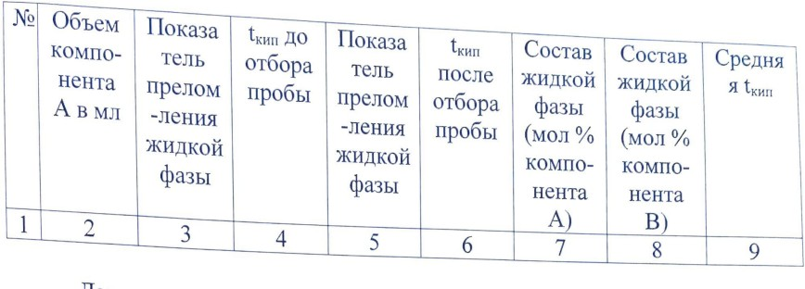
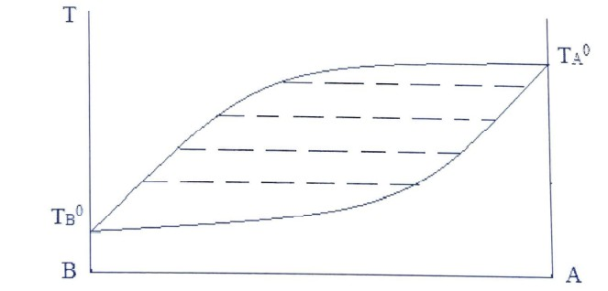
Further, according to the data in Table 1 presented in columns 7, 8, 9, a diagram is drawn between the temperature of the boiling point and the composition. On the abscissa axis, the composition is plotted in mol%, and on the ordinate axis, the boiling point of pure liquids and their mixtures. Each temperature (except for the boiling point of liquids) will correspond to two points corresponding to the composition of the liquid and vapor can be denoted in different ways. Next, we connect all the points corresponding to the composition of the liquid phase with one smooth line (liquid line), the points corresponding to the composition of the vapor phase with another line (vapor line) and obtain the state diagram of the system under study (Fig. 8)

Fig. 8 Evaporating temperature-composition diagram of AB system

Purpose of work:
Examine the diagram boiling point - composition of the two-component AB system.

Appliances and utensils:
1.Flasks for the preparation of mixtures.
2.Installation for determining the boiling point of liquids.
3.Refractometer.

Progress:
1.Prepare a mixture and determine their refractive indices.
2.Determine their boiling points, take samples to determine the composition of the vapor phase and determine their refractive indices.
3.Calculate the composition of the liquid phase in mol%, build a calibration curve and use it to find the composition of the vapor phase.

4.Data should be presented in the form of a table of the specified sample and a graph in the coordinates of boiling point - composition of the studied system.

Control questions
1.Ideal solution, its main features and conditions of formation.
2.Reasons for positive and negative deviations from Raoult's law.
3.The first and second laws of Konovalov. Explain them on the diagrams composition - boiling temperature, composition - pressure.

